Handout no. 1

|  |  |
| --- | --- |
| **Name** | Faizan Azam, Muhammad Asad |
| **Reg. No** | 2019-EE-381, 2019-EE-383  2019-EE-3 |
| **Marks/Grade** |  |

**EXPERIMENT # 1**

**Analysis of different basic Parameters to solve power flow and power operation techniques**.

**Objective:**

At the end of this lab session students will be able to

* To design Power system operations in in Power World Simulator.
* To observe power flow in power System.

**Introduction:**

Power World is a great and “powerful” utility for solving power flows. Solving a power system is a little different from circuit analysis. Instead of being given voltages at certain nodes or impedances, you are often given load and generator powers. This makes solving the circuit difficult to do by hand, but easy using a tool like Power World. Most utilities use Power World or similar programs for solving their systems, such as PSS/E.

Adding Power World to your CAE Start Menu:

1. Add Power World to your CAE start menu. In a CAE computer lab, click Start -> CAE Applications ->Add Applications to Start Menu, and search for Power World.

2. Launch Power World**.**

**Mode of Operations:**

There is two modes of operations.

* Run Mode
* Edit Mode

**Edit Mode of Operation:**

In edit mode of operation the network is designed. All changings of network is done in this mode of operation. The window of draw network is in Edit mode of operation in which options of drawing all components are presents.

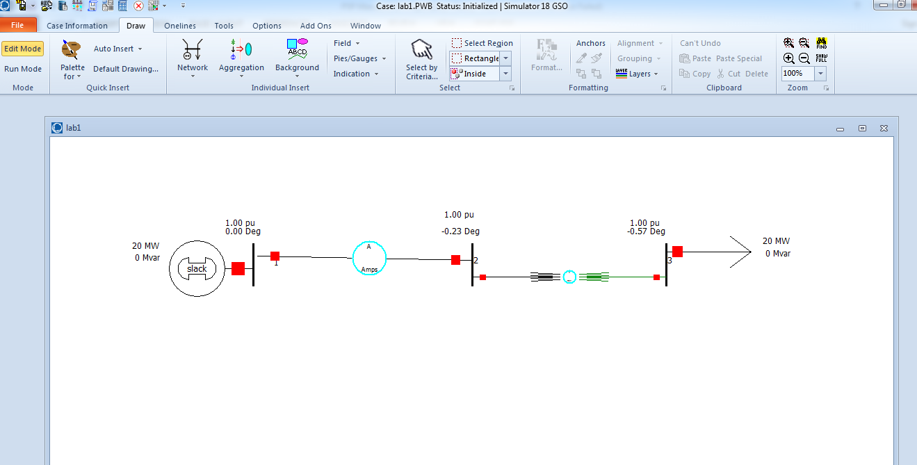

Figure No: 1

**Run Mode:**

In run mode system power flow is analysed. Active and reactive power at each bus is analysed. All fault analysis can be done in run mode of operation.

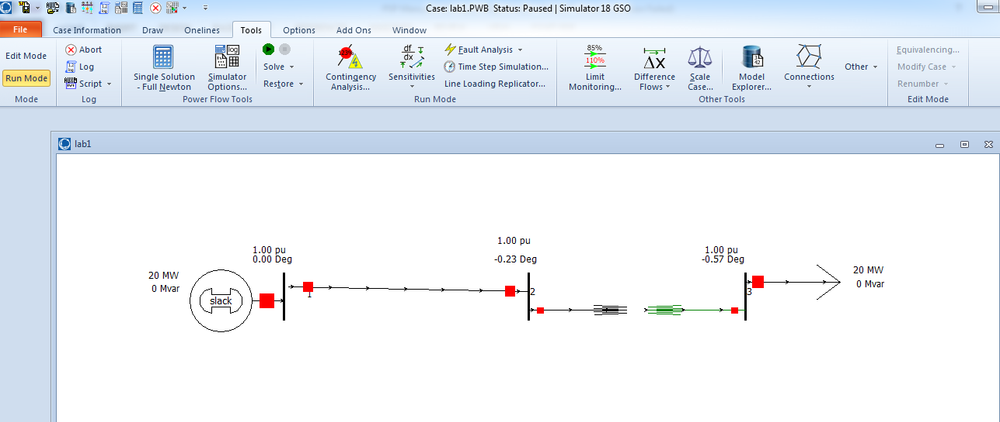

Figure No: 2

* **Tasks:**
* **Figure 1:**
* Load Flow Diagram
* **Edit mode**

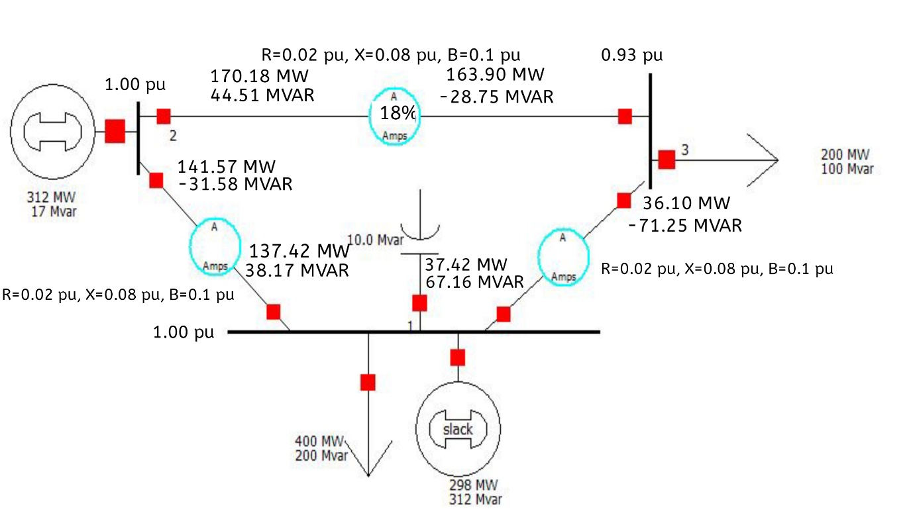

* **Run MODE:**



* **Figure 2:**
* Y-BUS

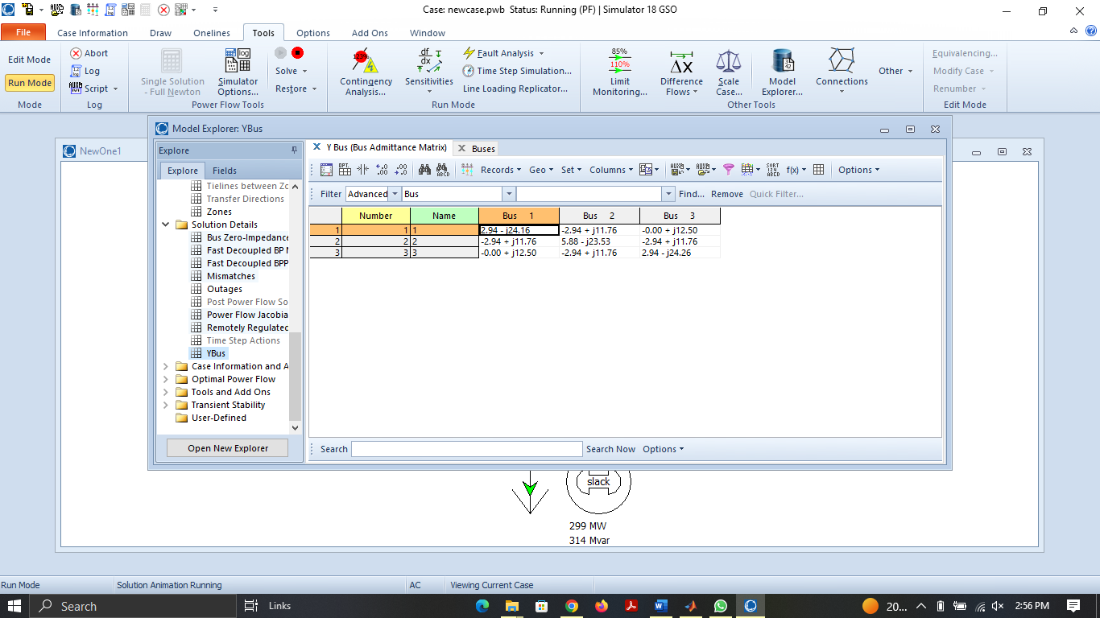

* **Figure 3:**
* Z-Bus

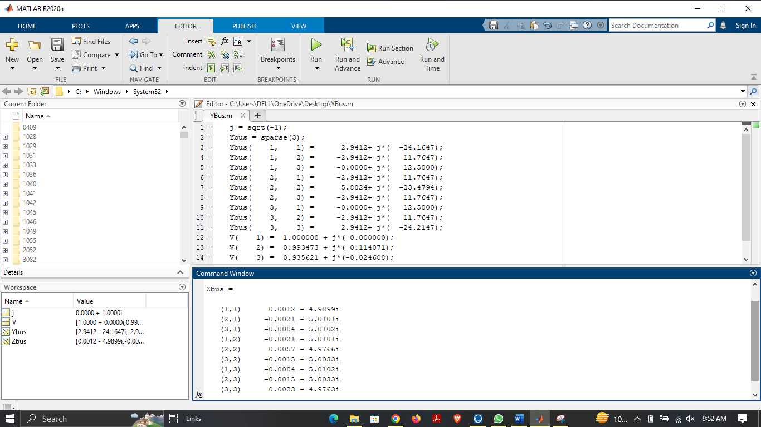

* **Comments and Observation:**

By performing this experiment during the lab, we were able to observe the effects of different system configurations and disturbances during the power flow. Through, designing a power system and observing the power flow through the system, we were able to gain a better understanding of how power systems work and the various factors that can affect the flow of power.

* **LOAD FLOW ANALYSIS IS ONE OF THE BASIC POWER SYSTEM ANALYSES IN THE STAGE OF PLANNING, DESIGN AND OPERATION OF POWER SYSTEMS. THIS IS USED TO CALCULATE THE STEADY STATE PERFORMANCE OF THE SYSTEM UNDER VARIOUS POSSIBLE OPERATING CONDITIONS AND STUDY THE EFFECTS OF CHANGES IN EQUIPMENT CONFIGURATION.**
* **Load Flow Analysis have following advantages:**
* **Optimize circuit usage.**
* **Develop practical voltage profiles.**
* **Minimize kW losses.**
* **Minimize kVar losses.**

**The load flow problem can be formulated as a set of non-liner algebraic equations, which can be solved by an iterative algorithm called Gauss method.**

* **There are three types of System Buses:**
* **PQ bus – the real power |P| and reactive power |Q| are specified. It is also known as Load Bus.**
* **PV bus – the real power |P| and the voltage magnitude |V| are specified. It is also known as Generator Bus.**
* **Slack bus – to balance the active and reactive power in the system.**